## **Overview**

It's time to dig deeper into our brands and start to define a voice and tone through a brand matrix. In this activity, you will articulate the voice and tone of your government agency website. The goal is to quickly identify descriptive adjectives for your UI brand and define where those descriptions should be used and not used.

## **Instructions**

#### **Part 1: Brand Voice and Tone Matrix (8 min)**

1. Gather in groups of two to four.
   * Make a copy of the [09.3-03-Brand Voice Analysis Identity Template](https://docs.google.com/spreadsheets/d/1yiS8MWDKGfcgXDC0Qh0sPb3-tz59vEEB5UwOD0hvUd0/edit?usp=sharing).
2. Familiarize yourself with the template. Look through each of the three tabs.
3. Define your brand voice and tone adjectives.
   * Review some examples on the first tab of the 01-Brand Voice Analysis Identify template spreadsheet.

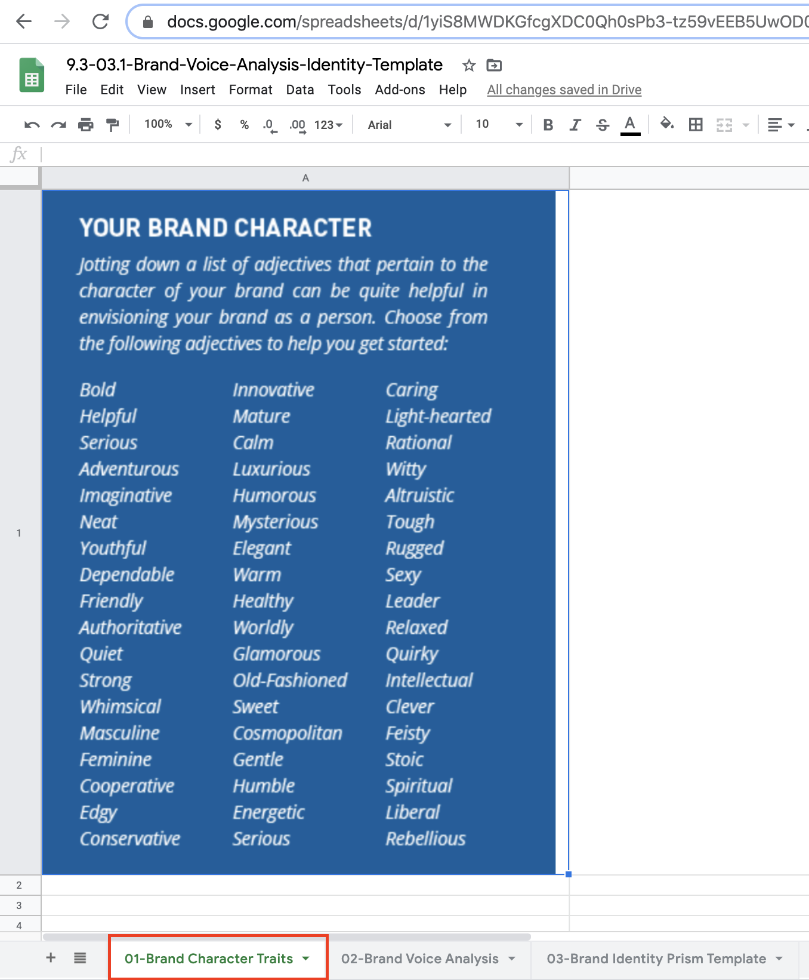

1. Pick three to five adjectives to complete.
2. Complete the second tab’s 02-Brand Voice Analysis Matrix with the Adjective, Description, Do, and Do Not columns.

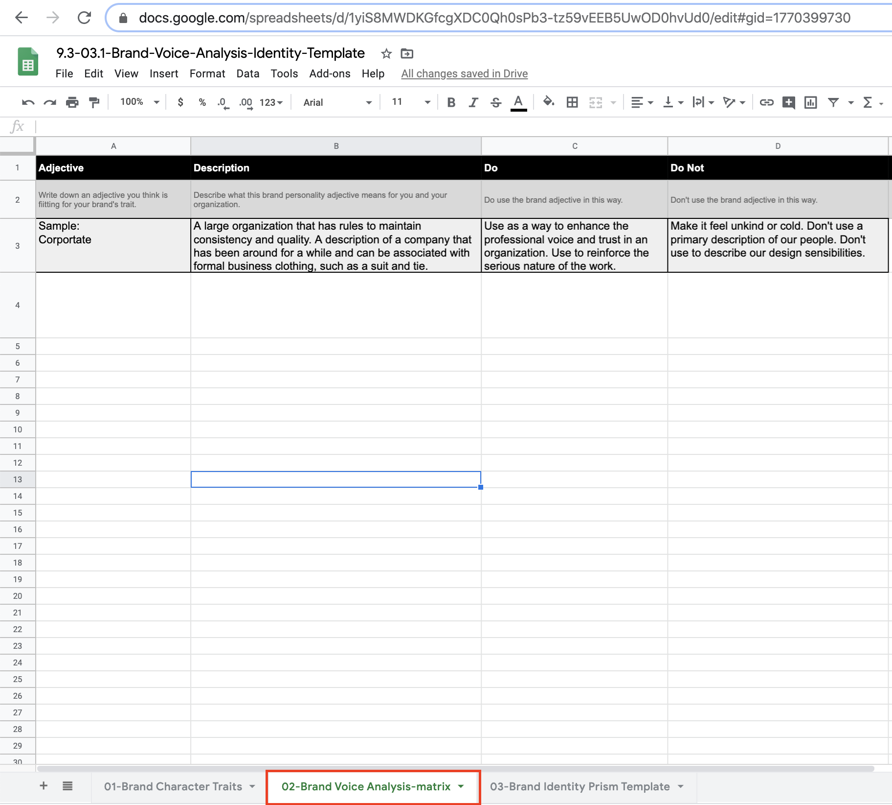

#### 

#### **Part 2: Brand Identity Prism (10 min)**

1. Move to the third tab of your sheet.

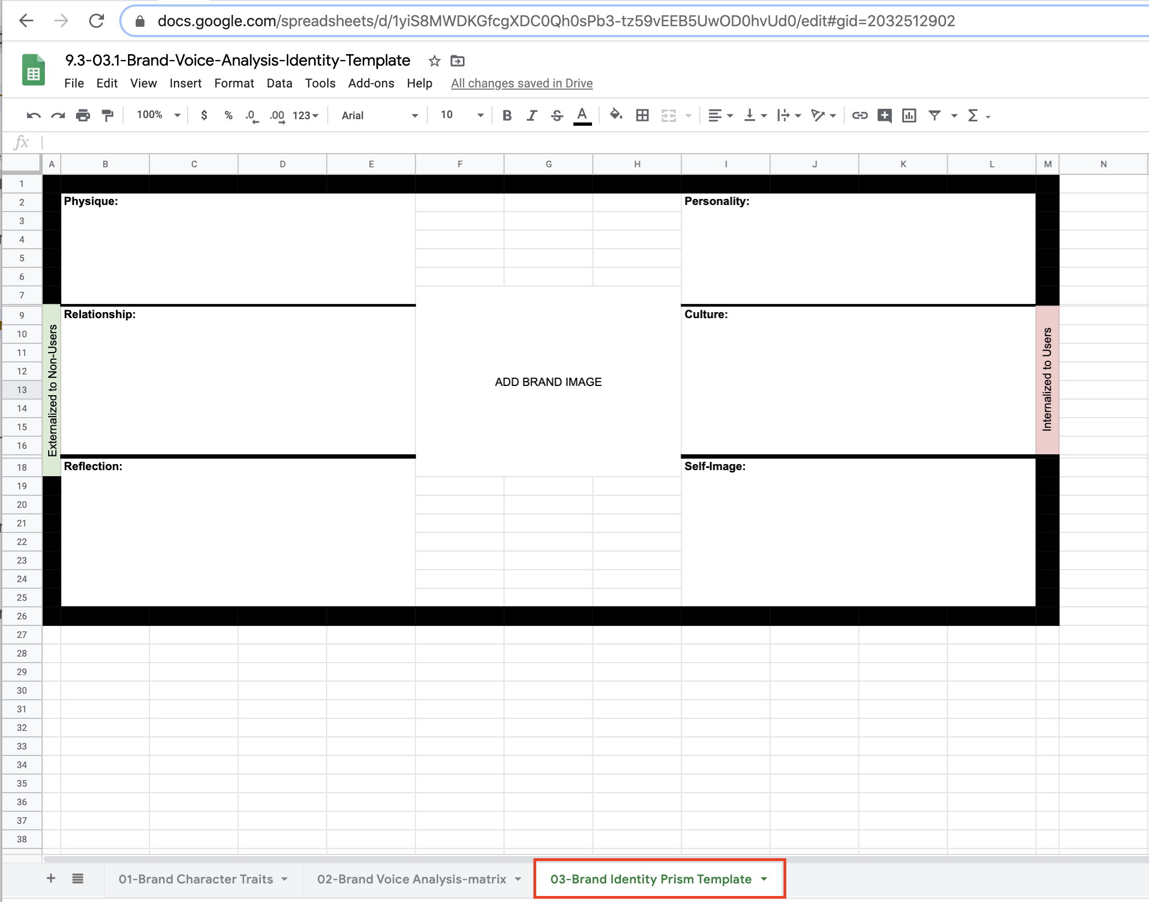

1. Complete the Brand Identity Prism.
   * Physique
   * Personality
   * Culture
   * Self-image
   * Reflection
   * Relationship

Bonus: Create a brand voice and tone matrix in Figma.

[Figma Sample](https://www.figma.com/file/ZRKdkyHaoKGGQsSoBdRwrk/09.3-03-Brand-Voice-Analysis-Identity-Template):

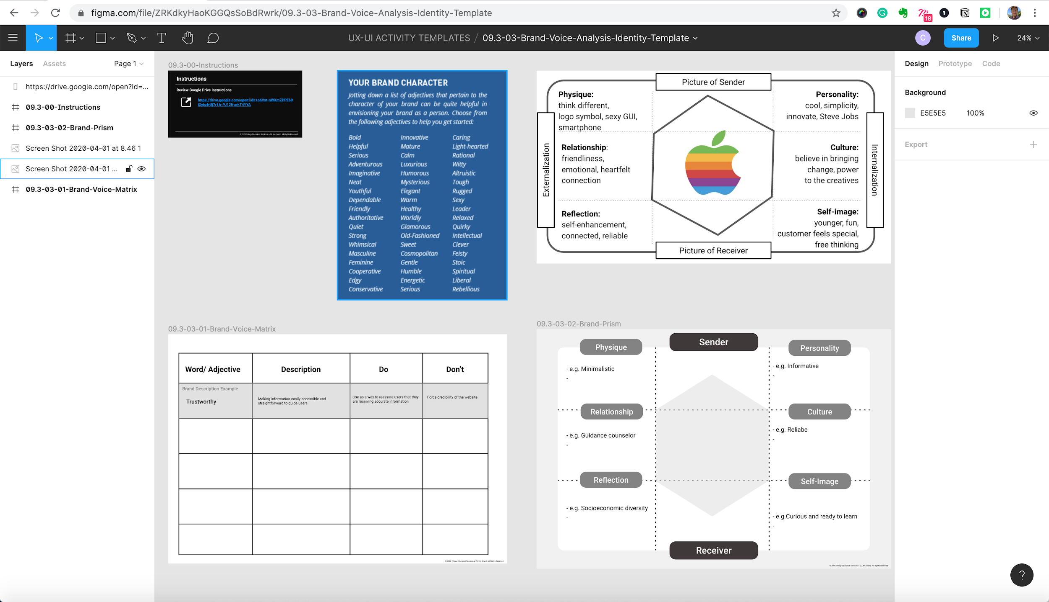

#### **Part 3: Share in Slack (2 min)**

1. Share a link to your brand voice matrix in Slack.
   * Make sure your sharing settings are set for “anyone can have access.”

**In the Real World**Brand articulation is part of the UX/UI design process, as the solutions you create are the tangible representations of the brand they are created for. Getting your clients and stakeholders to build these deliverables along with you will help in the long run of executing the brand visually.